- D filp-flop
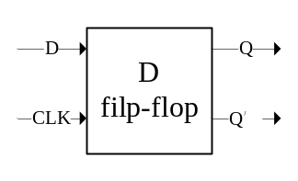
Truth table
D | CLK | Q(t+1)
0 | 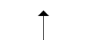 | 0
1 |  | 1
X | 0 | Q(t)
X | 1 | Q(t)

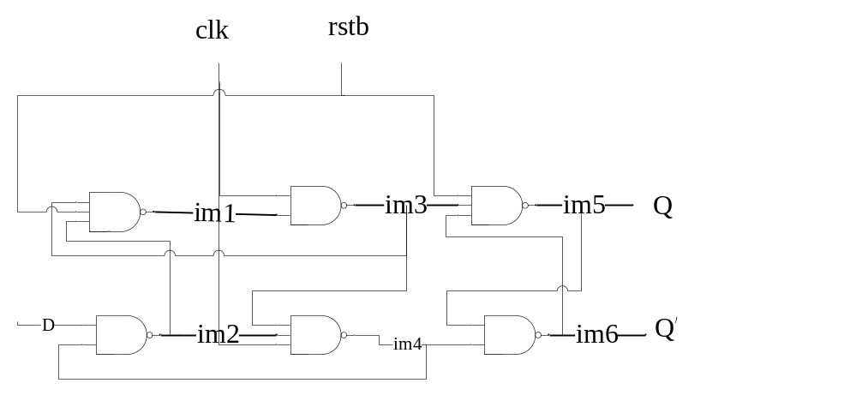
  - Dataflow
Code
entity dff is
port( d,clk,rstb : in bit;
q,not_q : out bit);
end entity;

architecture dataflow of dff is
begin
b0: block((clk='1' and not clk'stable) or rstb = '0')
begin
q <= guarded d when rstb = '1' else '0';
not_q <= guarded not d when rstb = '1' else '1';
end block b0;
end dataflow;

testbench
entity dff_tb is
end entity;

architecture io of dff_tb is
component dff is
port( d,clk,rstb: in bit;
q,not_q : out bit);
end component;

for all: dff use entity work.dff(dataflow);

signal d,clk,rstb,q,q_not : bit;

begin
c1: dff port map (d,clk,rstb,q,q_not);

d <= not d after 3ns;
clk <= not clk after 5ns;
rstb <= not rstb after 10ns;

end io;

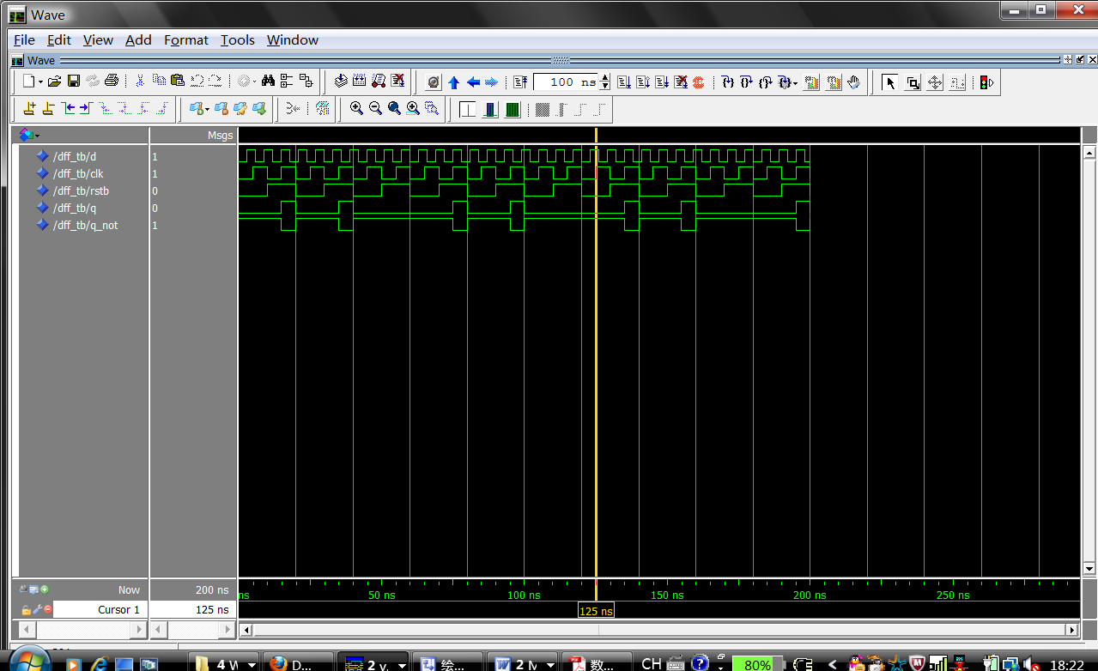
  - Structral
Code
entity dff_struct is
port( d, clk, rstb : in bit;
q, not_q: out bit);
end entity;

architecture struct of dff_struct is
component nand3_gate is
port(a,b,c: in bit;
d: out bit);
end component;

component nand2_gate is
port(a,b: in bit;
c: out bit);
end component;

for all: nand3_gate use entity work.nand3_gate(dataflow);
for all: nand2_gate use entity work.nand2_gate(dataflow);

signal im1,im2,im3,im4,im5,im6 : bit;

begin
g1: nand3_gate port map(im3,d,rstb,im1);
g2: nand2_gate port map(im4,im1,im2);
g3: nand3_gate port map(im1,clk,im4,im3);
g4: nand3_gate port map(clk,im2,rstb,im4);
g5: nand3_gate port map(im3,rstb,im6,im5);
g6: nand2_gate port map(im5,im4,im6);

q <= im6;
not_q <= im5;

end struct;

testbench
entity dff_struct_tb is
end entity;

architecture io of dff_struct_tb is
component dff_struct is
port( d,clk,rstb: in bit;
q,not_q : out bit);
end component;

for all: dff_struct use entity work.dff_struct(struct);

signal d,clk,rstb,q,q_not : bit;

begin
c1: dff_struct port map (d,clk,rstb,q,q_not);

d <= not d after 40ns;
clk <= not clk after 30ns;
rstb <= not rstb after 20ns;

end io;

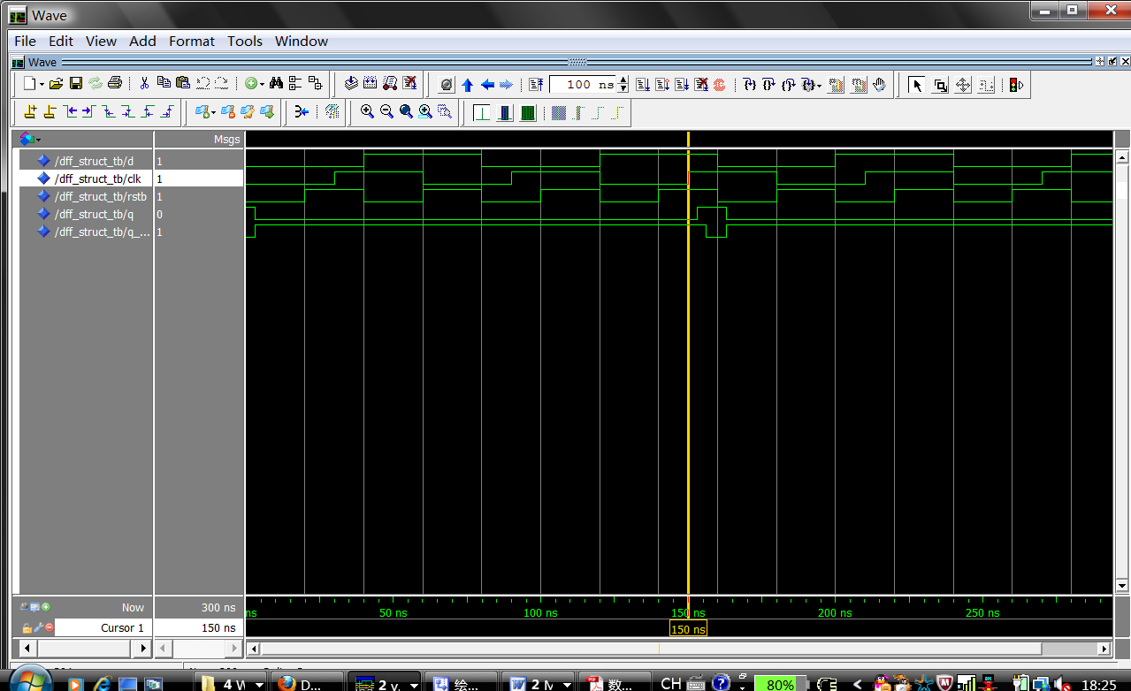

- overload and
code
library ieee;
use ieee.std_logic_1164.all;

package my_package is
type qit is ('x','0','1','z');
function "and" (a,b : qit) return qit;
end my_package;

package body my_package is

function "and" (a, b: qit) return qit is
type qit_table is array(qit,qit) of qit;
constant qit_and_table : qit_table :=
-- x 0 1 z
(
('x','0','x','x'),-- x
('0','0','0','0'),-- 0
('x','0','1','x'),-- 1
('x','0','x','x'));--z

begin
return qit_and_table(a,b);
end "and";

end my_package;

testbench
use work.my_package.all;
entity overload_and_qit_tb is
end entity;

architecture io of overload_and_qit_tb is
component overload_and_qit is
end component;

signal a,b,f : qit;

begin
a <= 'x', '0' after 40ns, '1' after 80ns, 'z' after 120ns;
b <= 'x', '0' after 10ns, '1' after 20ns, 'z' after 30ns, 'x' after 40ns,'0' after 50ns,'1' after 60ns, 'z' after 70ns,'x' after 80ns,'0' after 90ns,'1' after 100ns, 'z' after 110ns,'x' after 120ns,'0' after 130ns,'1' after 140ns, 'z' after 150ns;
f <= a and b;
end io;
